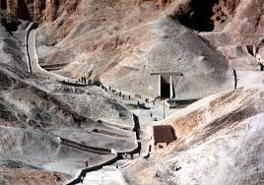Name____________________

Journey Into the Valley of the Kings
Directions : You are going to take a journey into the Valley of the Kings in Thebes and explore the many tombs of the pharaohs that have been unearthed by archeologists. You will start by going to this website http://www.thebanmappingproject.com and clicking on the link for Atlas of the Valley of the Kings. You will then be taken to the mapping of the individual tombs of the pharaohs. Here, you will watch an introductory movie, and then click on at least FOUR other tombs to explore.

Introduction
After watching the introductory movie on the Valley of the Kings, please write a 3-4 sentence summary on the information that you learned.

Tomb of the Pharaoh ___________________

Tomb of the Pharaoh ___________________

Tomb of the Pharaoh ___________________

Tomb of the Pharaoh ___________________

